Exercise 14:

**1. Describe the Process Step by Step**

**Problem**: Solve the quadratic equation ax2+bx+c=0, where a, b, and ccc are real numbers, and a≠0a \neq 0a=0.

**Steps**:

1. **Input values**: Read the values of a, b, and c.
2. **Check if it's a valid quadratic equation**:
   * If a=0a = 0a=0, the equation becomes linear (bx+c=0) and can be solved as a first-degree equation.
3. **Calculate the discriminant**:
   * Discriminant Δ=b2−4ac\Delta = b^2 - 4acΔ=b2−4ac.
4. **Check the discriminant**:
   * **If Δ>0\Delta > 0Δ>0**: The equation has two distinct real roots.
     + Compute the roots using the formulas:
       - x1=−b+Δ2ax_1 = \frac{-b + \sqrt{\Delta}}{2a}x1​=2a−b+Δ​​
       - x2=−b−Δ2ax_2 = \frac{-b - \sqrt{\Delta}}{2a}x2​=2a−b−Δ​​
     + Output both roots.
   * **If Δ=0\Delta = 0Δ=0**: The equation has one real root (a repeated root).
     + Compute the root using the formula:
       - x=−b2ax = \frac{-b}{2a}x=2a−b​
     + Output the root.
   * **If Δ<0\Delta < 0Δ<0**: The equation has no real roots but has two complex roots.
     + Compute the real and imaginary parts of the roots:
       - Real part =−b2a= \frac{-b}{2a}=2a−b​
       - Imaginary part =∣Δ∣2a= \frac{\sqrt{|\Delta|}}{2a}=2a∣Δ∣​​
     + Output both complex roots as:
       - x1=−b2a+∣Δ∣2aix_1 = \frac{-b}{2a} + \frac{\sqrt{|\Delta|}}{2a}ix1​=2a−b​+2a∣Δ∣​​i
       - x2=−b2a−∣Δ∣2aix_2 = \frac{-b}{2a} - \frac{\sqrt{|\Delta|}}{2a}ix2​=2a−b​−2a∣Δ∣​​i

**2. Describe the Process Through Flowchart**

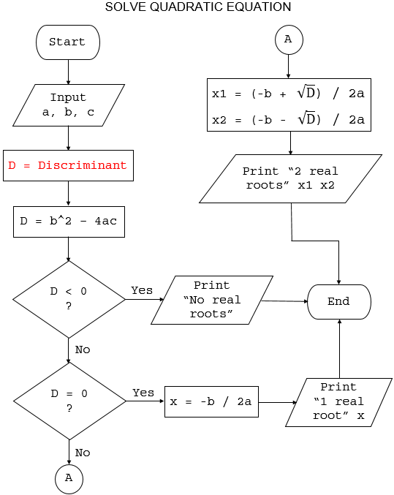

**3. Describe the Process Through Pseudocode**

Start

Input a, b, c

If a = 0 then

Solve bx + c = 0 (linear equation)

Print "Linear equation solution:", x

Else

Δ = b^2 - 4ac

If Δ > 0 then

x1 = (-b + sqrt(Δ)) / (2 * a)

x2 = (-b - sqrt(Δ)) / (2 * a)

Print "Two real roots: x1 =", x1, ", x2 =", x2

Else If Δ = 0 then

x = -b / (2 * a)

Print "One real root: x =", x

Else

realPart = -b / (2 * a)

imaginaryPart = sqrt(abs(Δ)) / (2 * a)

Print "Two complex roots: x1 =", realPart, "+", imaginaryPart, "i", ", x2 =", realPart, "-", imaginaryPart, "i"

End If

End If

End